PHASE 2 – CREATE SERVICE & SERVICE OFFERING
Incident Lifecycle Automation in ServiceNow
Implementation Documentation with ServiceNow Screenshot Evidence

1. Phase Objective
The objective of Phase 2 was to establish the ServiceNow service structure required for the incident lifecycle. A Business Service was created for IT Incident Management, followed by a Standard IT Support service offering under that service. These records provide the service context used later by the incident.

2. Service Created
The service named IT Incident Management Service was created in ServiceNow Service Portfolio.
Field | Configured Value
Name | IT Incident Management Service
Service classification | Business Service
Consumer type | Internal
Phase | Pipeline
Status | Requirements
Short Description | Service for managing IT incidents from creation through investigation, escalation, resolution and closure.

Screenshot Evidence – Service record
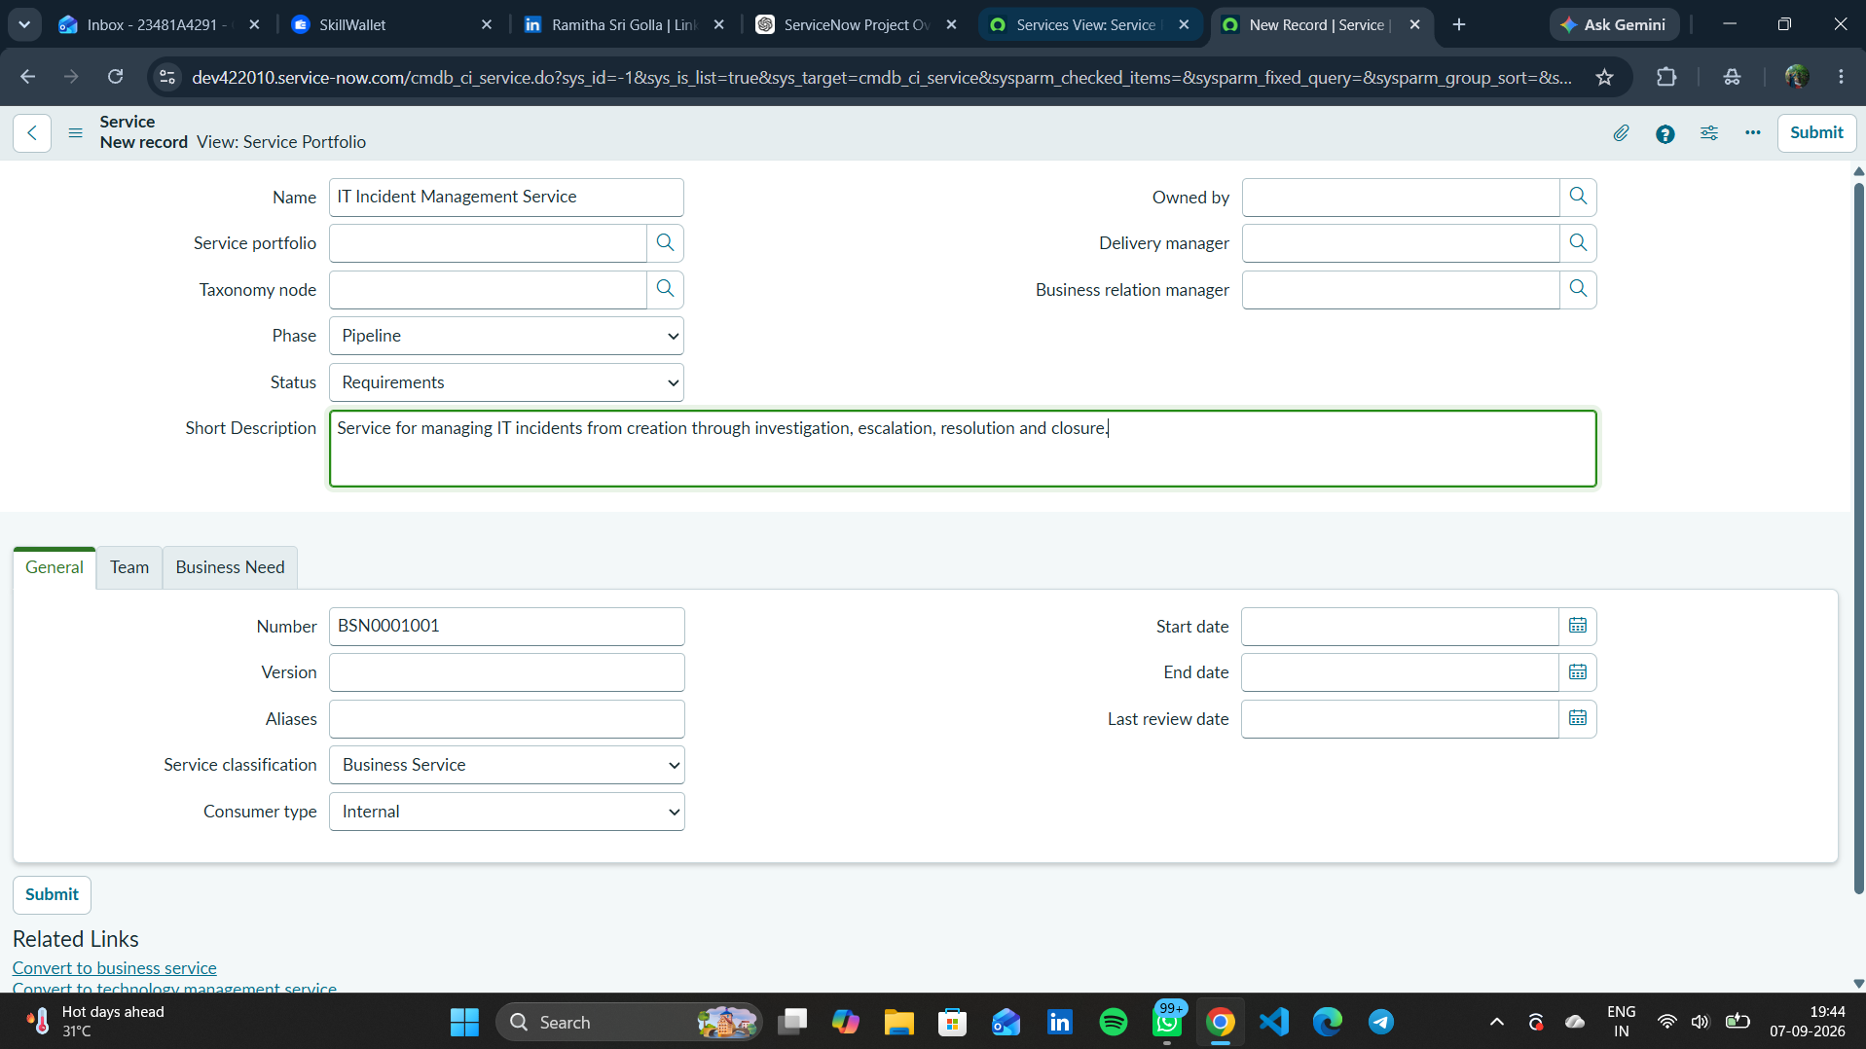
Figure 1. IT Incident Management Service created in ServiceNow.

3. Service Offering Created
A service offering named Standard IT Support was created under IT Incident Management Service. The offering represents the standard support capability used for incident reporting, investigation, escalation, knowledge-based troubleshooting, and resolution.
Field | Configured Value
Name | Standard IT Support
Parent | IT Incident Management Service
Phase | Pipeline
Status | Requirements
Short Description | Standard IT support offering for incident reporting, investigation, escalation and resolution.
Description | Provides standard IT support for reporting, classifying, assigning, investigating, escalating and resolving incidents. The service supports knowledge-based resolution and integration with change management when required.

Screenshot Evidence – Service Offering record
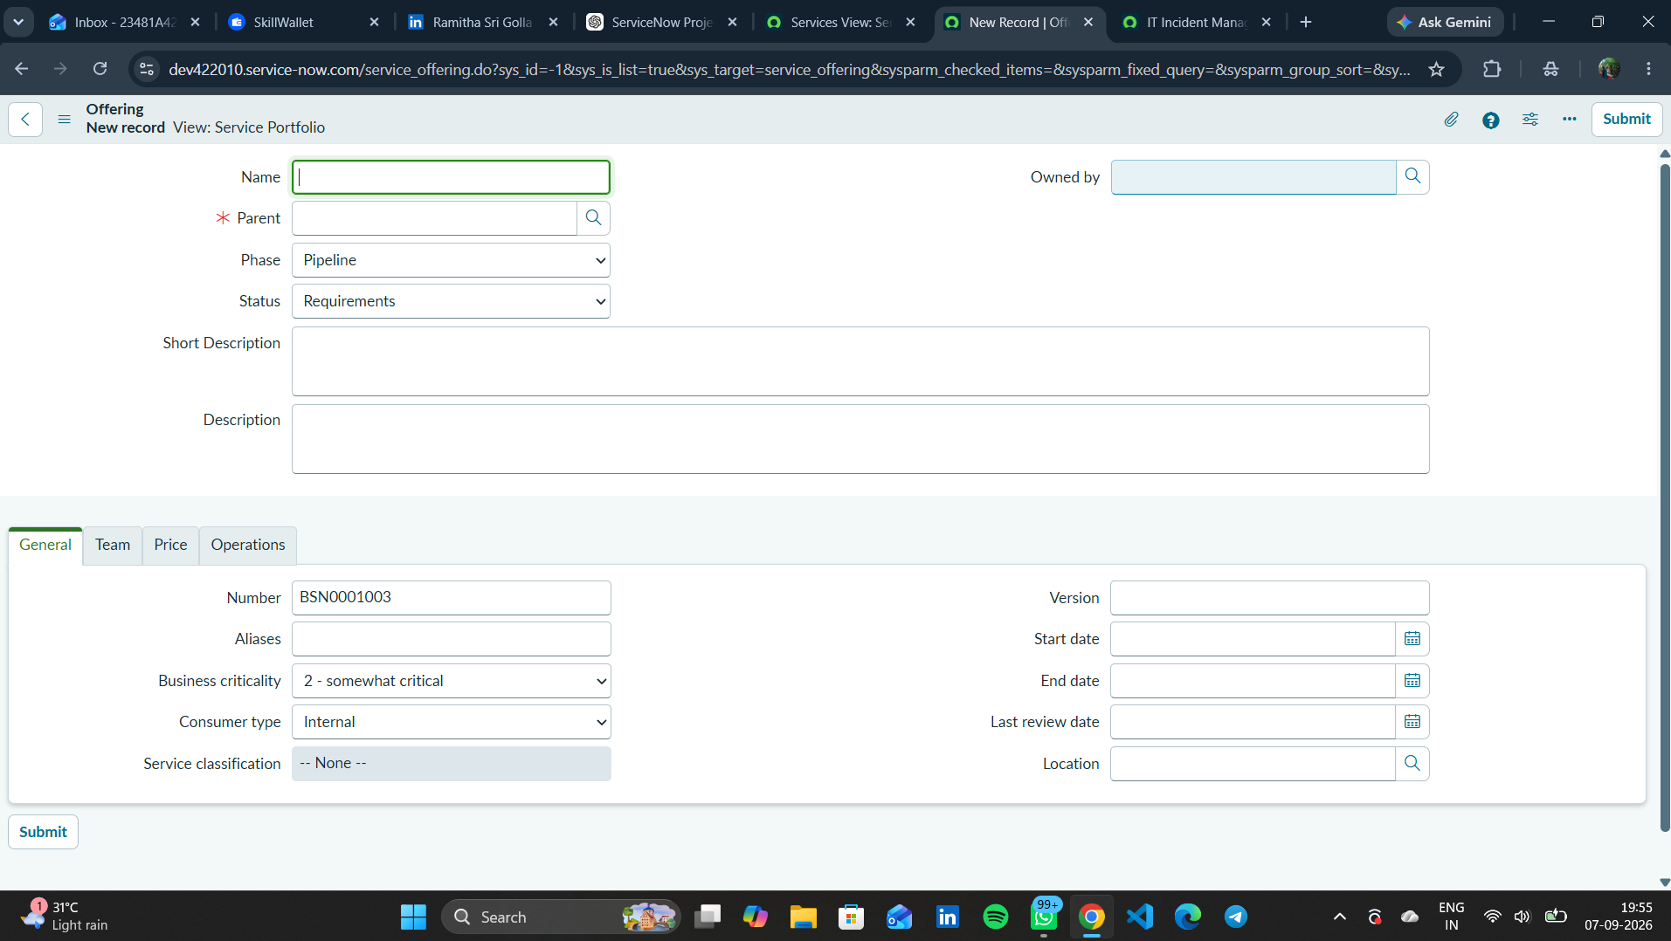
Figure 2. Standard IT Support service offering created under the IT Incident Management Service.

4. Verification Evidence
The Service Portfolio and Service Offering list views were checked after creation. The screenshots below show the records present in ServiceNow.
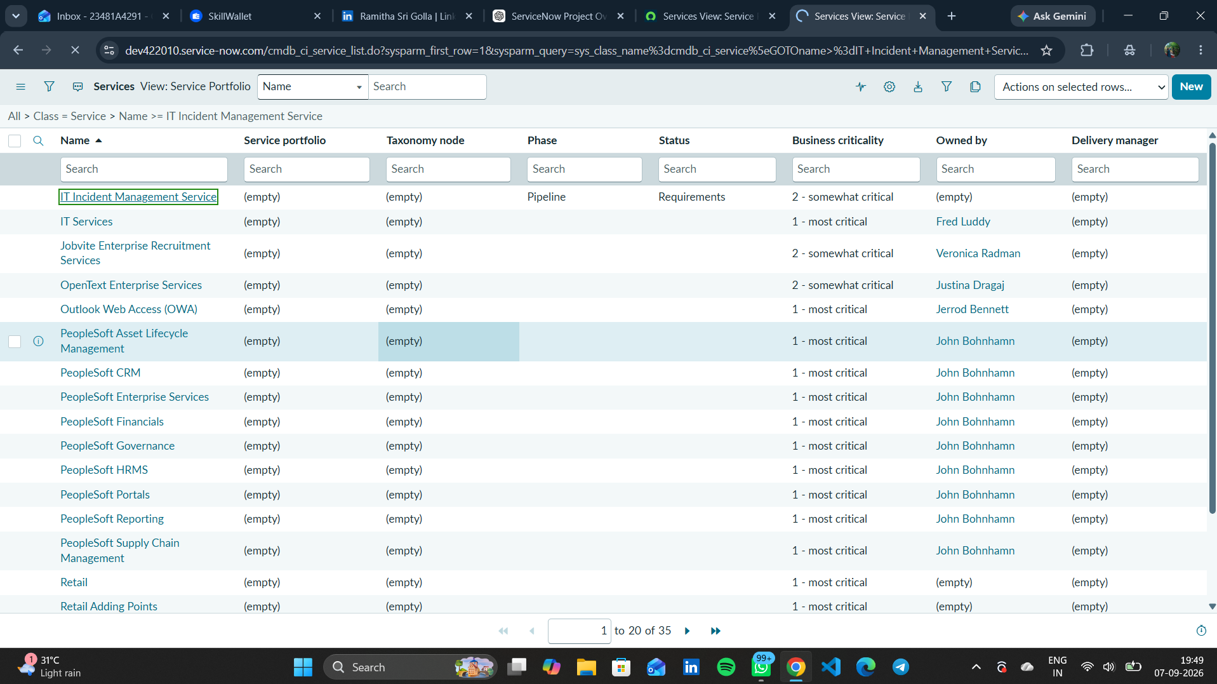
Figure 3. Service Portfolio view showing IT Incident Management Service.
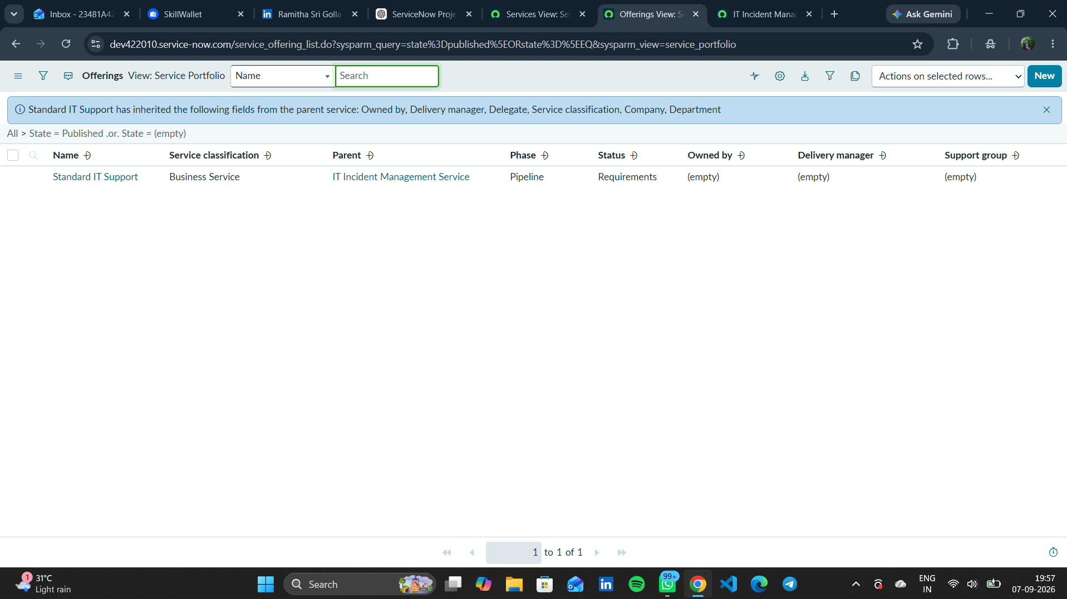
Figure 4. Service Offering list showing Standard IT Support under the parent service.

5. Phase 2 Outcome
- IT Incident Management Service was successfully created.
- The service was classified as a Business Service for Internal consumers.
- Standard IT Support was successfully created as a child service offering.
- The service structure was ready for use by the incident record in the next implementation phase.
Status: COMPLETED

6. Phase 2 Evidence Files
- 01_service_list_before.png
- 02_service_created.png
- 03_service_offering_created.png
- 04_service_offering_list.png

